# **Multi-task analysis**

## **Section 1: Multi-task**

#### **Research Objectives:**

(1). Verify whether our proposed Gabor Picture (GP) and Gabor Feature (GF) systems can generate speech on multiple speakers (Seen-speaker Task and Unseen-speaker Task).

(2). Examine the impact of the number of speakers on the Gabor Picture (GP) and Gabor Feature (GF) systems and compare their results with the Lip2AudSpec (CNN) system.

(3). Evaluate the generated speech on the Gabor Picture (GP) and Gabor Feature (GF) systems and compare their performance with Lip2AudSpec (CNN) system on the multiple speaker’s task.

#### **Results**:

(1). The reconstructed speech results shows that our Gabor Feature (GF) system can reconstruct intelligent speech from multiple seen speakers, our Gabor Feature (GF) system can generate partial speech, while the Lip2AudSpec (CNN) system cannot reconstruct intelligible speech. For multiple unseen tasks, none of those systems can generate intelligent speech from multiple unseen speakers. But our Gabor Feature (GF) system slightly improves the accuracy of reconstructed spectrogram as the number of speakers increases.

(2). The metrics results verified the Gabor Feature (GF) system outperforms the Gabor Picture (GP) system and the Lip2AudSpec (CNN) system in multi-speaker tasks. The Gabor Feature (GF) system maintains high spectrogram accuracy, speech quality, overall speech quality, and speech intelligibility across different numbers of speakers. Furthermore, the average level of speech intelligibility slightly increases as the number of speakers increases.

In the Gabor Picture (GP) system, its average speech intelligibility remains stable across the multi-speaker tasks. However, as the number of speakers increases, its spectrogram accuracy, speech quality and overall speech quality decrease. Especially when the number of speakers increases to four, its spectrogram accuracy drops rapidly. And its speech quality and overall speech quality decreased when the number of speakers increased to four, and slightly increased slightly after the number of speakers increased to more than four.

For comparison, we also tested the Lip2AudSpec (CNN) system on the multi-speaker task. The results show that the Lip2AudSpec (CNN) system has the worst spectrogram accuracy, speech quality, speech overall quality and speech intelligibility compared to our proposed systems. Especially when the number of speakers increases to two, its spectrogram accuracy drops rapidly and continues to decline as the number of speakers increases. And its speech quality, overall speech quality and intelligibility also drops rapidly when the number of speakers increases to two, and then fluctuate around relatively low values as the number of speakers increases.

*The following conclusions can be drawn from the test results:*

Our proposed Gabor-based speech reconstruction systems achieve excellent results in both single-speaker and multi-speaker tests. In particular, the Gabor Feature (GF) system can reconstruct intelligible speech in both tests.

Compared with existing speech reconstruction systems such as Lip2AudSpec (CNN) systems that can only learn the speaking style of a single speaker, our Gabor-based speech reconstruction system can learn not only individual speaking style but also multiple speaking styles.

This breaks the limitation that existing speech reconstruction systems can only be used in one -person scenarios, broadens the practical applications of speech reconstruction systems in multi-speaker scenarios.

## **Section 2: Dataset-Grid Corpus**

|  |  |  |
| --- | --- | --- |
| Seen speaker task [4 males. 4 females] | | |
| Speaker | Sample | Gender |
| S1 | 100 | Male |
| S10 | 100 | Male |
| S17 | 100 | Male |
| S27 | 100 | Male |
| S11 | 100 | Female |
| S15 | 100 | Female |
| S16 | 100 | Female |
| S25 | 100 | Female |
| Unseen speaker task [1 male. 1 female] | | |
| S13 | 100 | Male |
| S23 | 100 | Female |

## **Section 3: Experimental design**

**Multi-seen task:** Select 2 male speakers (S1, S27) and 2 female speakers (S16, S25) from the training speakers to test their generated speech on multiple task models.

**Multi-seen task:** Select 1 male and 1 female speaker from the non-training speakers to test their generated speech on multiple task models.

|  |  |  |  |
| --- | --- | --- | --- |
| Multi-Tasks | | Seen Task | Unseen Task |
| Multi-Speaker | Training speaker | Test speaker | Test speaker |
| 1-S | S1 (male) | S1 | S13 |
| S25 (male) | S25 | --- |
| S16 (female) | S16 | S23 |
| S27 (female) | S27 | --- |
| 2-S | S1-S27 (2 males) | S1, S27 | S13 |
| S16-S25 (2 females) | S16, S25 | S23 |
| 4-S | S1-S25-S16-S27  (2males, 2 females) | S1, S27, S16, S25 | S13, S23 |
| 6-S | S1-S17-S27-S16-S15-S27  (3 males, 3 females) | S1, S27, S16, S25 | S13, S23 |
| 8-S | S1-S10-S17-S27-S16-S11-S15-S27  (4 males, 4 females) | S1, S27, S16, S25 | S13, S23 |

## **Section 4: Evaluation**

**Corr2D**: measures the accuracy of the reconstructed auditory spectrogram.

**PESQ**: measures the reconstructed speech quality in the time domain.

**Overall Speech Quality:**  evaluates the overall quality (LLR, PESQ and WSS) of a speech.

**STOI:** is a correlation-based metric used to quantify the speech intelligibility.

**Spectrogram / Waveform and Audio / Video**

## **Section 5: Results**

## **5.1 Reconstructed speech from Speaker 1**

## *(Double click the follow picture to play the video)*



## **5.2 Reconstructed speech from Speaker 27**

## *(Double click the follow picture to play the video)*



## **5.3 Reconstructed speech from Speaker 16**

*(Double click the follow picture to play the video)*



## **5.4 Reconstructed speech from Speaker 25**

*(Double click the follow picture to play the video)*



## **Section 6: Result analysis**

### **6.1 multi-seen result**

1. Gabor Feature (GF) system outperforms the Gabor Picture (GP) system and the Lip2AudSpec (CNN) system in multi-speaker tasks. The Gabor Feature (GF) system maintains high spectrogram accuracy, speech quality, overall speech quality, and speech intelligibility across different numbers of speakers. Furthermore, the average level of speech intelligibility slightly increases as the number of speakers increases.

2. In the Gabor Picture (GP) system, its average speech intelligibility remains stable across the multi-speaker tasks. However, as the number of speakers increases, its spectrogram accuracy, speech quality and overall speech quality decrease. Especially when the number of speakers increases to four, its spectrogram accuracy drops rapidly. And its speech quality and overall speech quality decreased when the number of speakers increased to four, and slightly increased slightly after the number of speakers increased to more than four.

3. The results show that the Lip2AudSpec (CNN) system has the worst spectrogram accuracy, speech quality, speech overall quality and speech intelligibility compared to our proposed systems. Especially when the number of speakers increases to two, its spectrogram accuracy drops rapidly and continues to decline as the number of speakers increases. And its speech quality, overall speech quality and intelligibility also drops rapidly when the number of speakers increases to two, and then fluctuate around relatively low values as the number of speakers increases.

|  |  |
| --- | --- |
|  |  |
|  |  |

**6.2 Detailed analysis on each speaker**

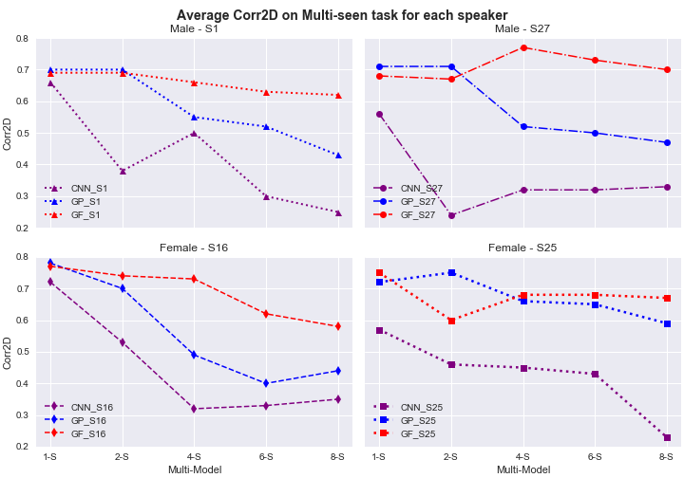

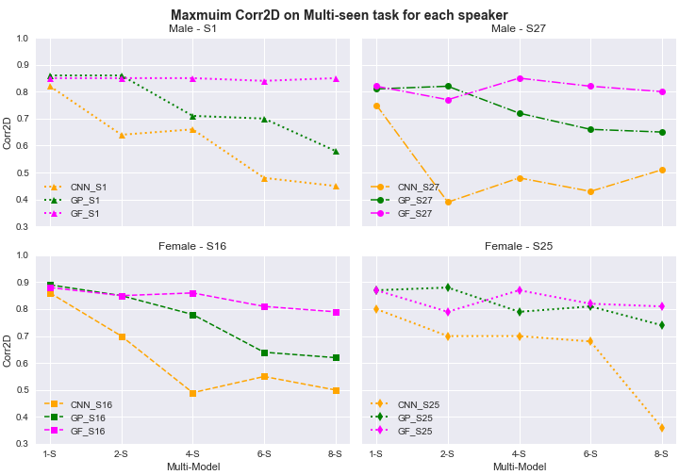

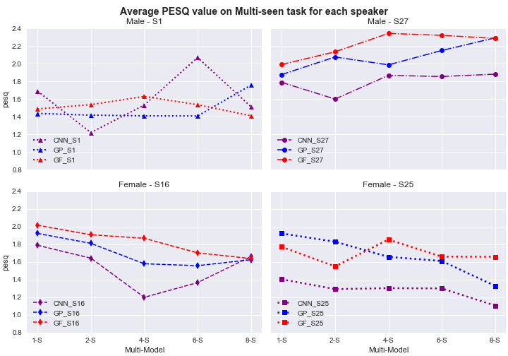

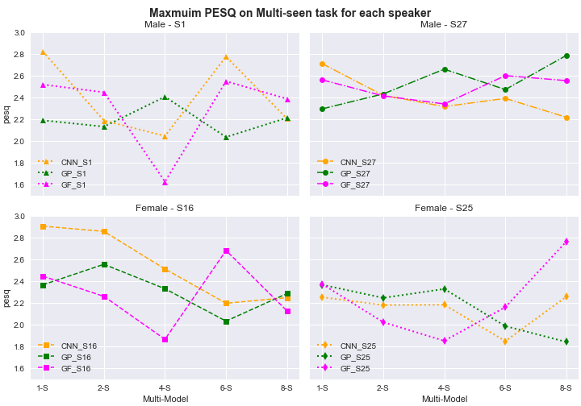

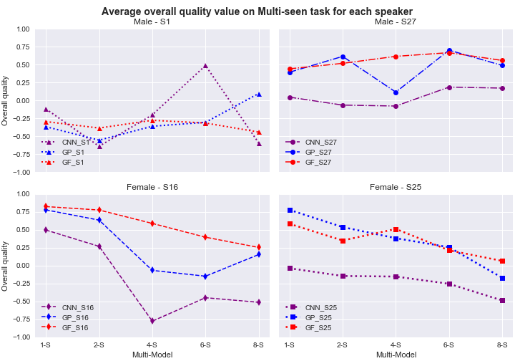

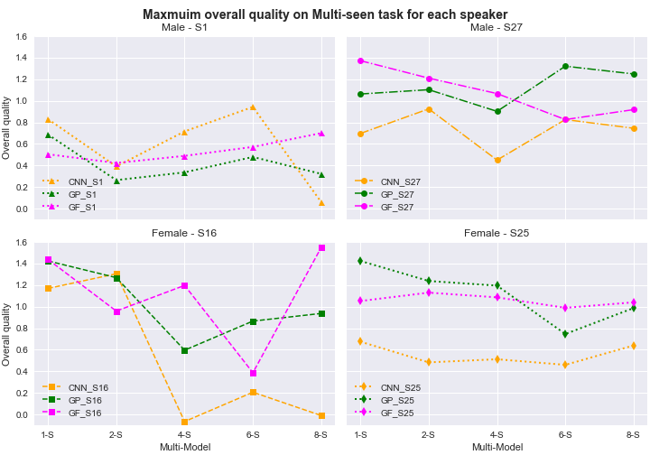

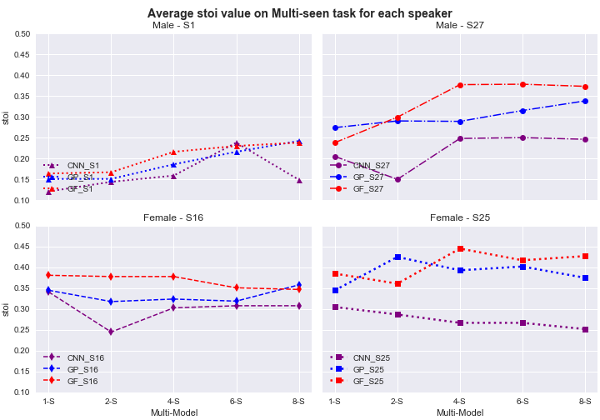

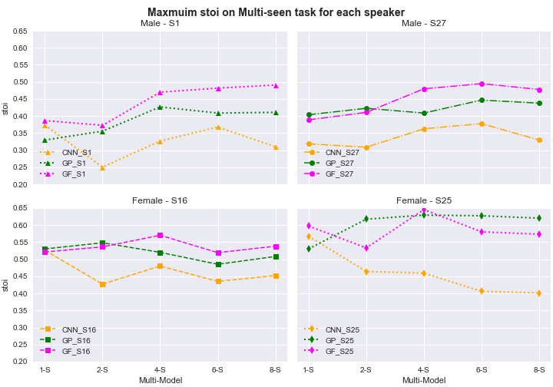

**Section 7: Result on reconstructed spectrogram**

**7.1 Reconstructed spectrogram from male speaker 1.**

*Sample sentence: “BIN BLUE BY F EIGHT PLEASE”*

|  |  |  |  |  |
| --- | --- | --- | --- | --- |
| **8-S** | a(5).8-S | b(5).8-S | c(5). 8-S |  |
| **6-S** | a(4).6-S | b(4).6-S | c(4).6-S |  |
| **4-S** | a(3).4-S | b(3).4-S | c(3).4-S | i(0) |
| **2-S** | a(2). 2-S | b(2).2-S | c(2).2-S |  |
| **1-S** | a(1).1-S | b(1).1-S | c(1). 1-S |  |
|  | **a. Lip2AudSpec system** | **b. GaborLip2AudSpec** | **c. GaborFea2AudSpec** | **i. Original** |

Figure. Comparing the reconstructed spectrogram between our proposed systems (System I: GaborLip2AudSpec b(1)-b(5), System II: Gabor2AudSpec c(1)-c(5)) and the Lip2AudSpec system a(1)-a(5)), using randomly selected sentences: BIN BLUE BY F EIGHT PLEASE

**7.2 Reconstructed spectrogram from male speaker 27.**

*Sample sentence: “BIN BLUE BY P EIGHT NOW”*

|  |  |  |  |  |
| --- | --- | --- | --- | --- |
| **8-S** | a(5).8-S | b(5).8-S | c(5). 8-S |  |
| **6-S** | a(4).6-S | b(4).6-S | c(4).6-S |  |
| **4-S** | a(3).4-S | b(3).4-S | c(3).4-S | i(0) |
| **2-S** | a(2). 2-S | b(2).2-S | c(2).2-S |  |
| **1-S** | a(1).1-S | b(1).1-S | c(1). 1-S |  |
|  | **a. Lip2AudSpec system** | **b. GaborLip2AudSpec** | **c. GaborFea2AudSpec** | **i. Original** |

Figure. Comparing the reconstructed spectrogram between our proposed systems (System I: GaborLip2AudSpec b(1)-b(5), System II: Gabor2AudSpec c(1)-c(5)) and the Lip2AudSpec system a(1)-a(5)), using randomly selected sentences: BIN BLUE BY P EIGHT NOW

**7.3 Reconstructed spectrogram from female speaker 16.**

*Sample sentence: “BIN GREEN AGAIN L NINE NOW”*

|  |  |  |  |  |
| --- | --- | --- | --- | --- |
| **8-S** | a(5).8-S | b(5).8-S | c(5). 8-S |  |
| **6-S** | a(4).6-S | b(4).6-S | c(4).6-S |  |
| **4-S** | a(3).4-S | b(3).4-S | c(3).4-S | i(0) |
| **2-S** | a(2). 2-S | b(2).2-S | c(2).2-S |  |
| **1-S** | a(1).1-S | b(1).1-S | c(1). 1-S |  |
|  | **a. Lip2AudSpec system** | **b. GaborLip2AudSpec** | **c. GaborFea2AudSpec** | **i. Original** |

Figure. Comparing the reconstructed spectrogram between our proposed systems (System I: GaborLip2AudSpec b(1)-b(5), System II: Gabor2AudSpec c(1)-c(5)) and the Lip2AudSpec system a(1)-a(5)), using randomly selected sentences: BIN GREEN AGAIN L NINE NOW

**7.4 Reconstructed spectrogram from male speaker 25**

*Sample sentence: “BIN BLUE WITH X EIGHT NOW”*

|  |  |  |  |  |
| --- | --- | --- | --- | --- |
| **8-S** | a(5).8-S | b(5).8-S | c(5). 8-S |  |
| **6-S** | a(4).6-S | b(4).6-S | c(4).6-S |  |
| **4-S** | a(3).4-S | b(3).4-S | c(3).4-S | i(0) |
| **2-S** | a(2). 2-S | b(2).2-S | c(2).2-S |  |
| **1-S** | a(1).1-S | b(1).1-S | c(1). 1-S |  |
|  | **a. Lip2AudSpec system** | **b. GaborLip2AudSpec** | **c. GaborFea2AudSpec** | **i. Original** |

Figure. Comparing the reconstructed spectrogram between our proposed systems (System I: GaborLip2AudSpec b(1)-b(5), System II: Gabor2AudSpec c(1)-c(5)) and the Lip2AudSpec system a(1)-a(5)), using randomly selected sentences: BIN BLUE WITH X EIGHT NOW

**Section 8: Result on reconstructed waveform**

**8.1 Reconstructed spectrogram from male speaker 1.**

*Sample sentence: “BIN BLUE BY F EIGHT PLEASE”*

|  |  |  |  |  |
| --- | --- | --- | --- | --- |
| **8-S** | a(5).6-S | b(5).8-S | c(5). 8-S |  |
| **6-S** | a(4).6-S | b(4).6-S | c(4).6-S |  |
| **4-S** | a(3).4-S | b(3).4-S | c(3).4-S | i(0) |
| **2-S** | a(2). 2-S | b(2).2-S | c(2).2-S |  |
| **1-S** | a(1).1-S | b(1).1-S | c(1). 1-S |  |
|  | **a. Lip2AudSpec system** | **b. GaborLip2AudSpec** | **c. GaborFea2AudSpec** | **i. Original** |

Figure. Comparing the reconstructed waveform between our proposed systems (System I: GaborLip2AudSpec b(1)-b(5), System II: Gabor2AudSpec c(1)-c(5)) and the Lip2AudSpec system a(1)-a(5)), using randomly selected sentences: BIN BLUE BY F EIGHT PLEASE

**8.2 Reconstructed spectrogram from male speaker 27.**

*Sample sentence: “BIN BLUE BY P EIGHT NOW”*

|  |  |  |  |  |
| --- | --- | --- | --- | --- |
| **8-S** | a(5).6-S | b(5).8-S | c(5). 8-S |  |
| **6-S** | a(4).6-S | b(4).6-S | c(4).6-S |  |
| **4-S** | a(3).4-S | b(3).4-S | c(3).4-S | i(0) |
| **2-S** | a(2). 2-S | b(2).2-S | c(2).2-S |  |
| **1-S** | a(1).1-S | b(1).1-S | c(1). 1-S |  |
|  | **a. Lip2AudSpec system** | **b. GaborLip2AudSpec** | **c. GaborFea2AudSpec** | **i. Original** |

Figure. Comparing the reconstructed waveform between our proposed systems (System I: GaborLip2AudSpec b(1)-b(5), System II: Gabor2AudSpec c(1)-c(5)) and the Lip2AudSpec system a(1)-a(5)), using randomly selected sentences: BIN BLUE BY F EIGHT PLEASE

**8.3 Reconstructed spectrogram from female speaker 16.**

*Sample sentence: “BIN GREEN AGAIN L NINE NOW”*

|  |  |  |  |  |
| --- | --- | --- | --- | --- |
| **8-S** | a(5).6-S | b(5).8-S | c(5). 8-S |  |
| **6-S** | a(4).6-S | b(4).6-S | c(4).6-S |  |
| **4-S** | a(3).4-S | b(3).4-S | c(3).4-S | i(0) |
| **2-S** | a(2). 2-S | b(2).2-S | c(2).2-S |  |
| **1-S** | a(1).1-S | b(1).1-S | c(1). 1-S |  |
|  | **a. Lip2AudSpec system** | **b. GaborLip2AudSpec** | **c. GaborFea2AudSpec** | **i. Original** |

Figure. Comparing the reconstructed waveform between our proposed systems (System I: GaborLip2AudSpec b(1)-b(5), System II: Gabor2AudSpec c(1)-c(5)) and the Lip2AudSpec system a(1)-a(5)), using randomly selected sentences: BIN BLUE BY F EIGHT PLEASE

**8.4 Reconstructed spectrogram from female speaker 25.**

*Sample sentence: “BIN BLUE WITH X EIGHT NOW”*

|  |  |  |  |  |
| --- | --- | --- | --- | --- |
| **8-S** | a(5).6-S | b(5).8-S | c(5). 8-S |  |
| **6-S** | a(4).6-S | b(4).6-S | c(4).6-S |  |
| **4-S** | a(3).4-S | b(3).4-S | c(3).4-S | i(0) |
| **2-S** | a(2). 2-S | b(2).2-S | c(2).2-S |  |
| **1-S** | a(1).1-S | b(1).1-S | c(1). 1-S |  |
|  | **a. Lip2AudSpec system** | **b. GaborLip2AudSpec** | **c. GaborFea2AudSpec** | **i. Original** |

Figure. Comparing the reconstructed waveform between our proposed systems (System I: GaborLip2AudSpec b(1)-b(5), System II: Gabor2AudSpec c(1)-c(5)) and the Lip2AudSpec system a(1)-a(5)), using randomly selected sentences: BIN BLUE BY F EIGHT PLEASE

**Section 9: Result on reconstructed audio**

|  |  |  |  |  |  |  |
| --- | --- | --- | --- | --- | --- | --- |
| **Reconstructed audio from male speaker 1**  **[***bin blue by f 8 please***]** | | | | |  | |
|  | **1-S** | **2-S** | **4-S** | **6-S** | | **8-S** |
| GF_SYS |  |  |  |  | |  |
| GP_SYS |  |  |  |  | |  |
| CNN_SYS |  |  |  |  | |  |
| **Reconstructed audio from male speaker 27**  **[***bin blue by p 8 now***]** | | | | |  | |
| GF_SYS |  |  |  |  | |  |
| GP_SYS |  |  |  |  | |  |
| CNN_SYS |  |  |  |  | |  |
| **Reconstructed audio from female speaker 16**  **[***bin green again l 9 now***]** | | | | |  | |
| GF_SYS |  |  |  |  | |  |
| GP_SYS |  |  |  |  | |  |
| CNN_SYS |  |  |  |  | |  |
| **Reconstructed audio from female speaker 25**  **[***bin blue with x 8 now***]** | | | | |  | |
| GF_SYS |  |  |  |  | |  |
| GP_SYS |  |  |  |  | |  |
| CNN_SYS |  |  |  |  | |  |

**Section 10: Result on reconstructed clear audio**

|  |  |  |  |  |  |  |
| --- | --- | --- | --- | --- | --- | --- |
| **Reconstructed audio from male speaker 1**  **[***bin blue by f 8 please***]** | | | | |  | |
|  | **1-S** | **2-S** | **4-S** | **6-S** | | **8-S** |
| GF_SYS |  |  |  |  | |  |
| GP_SYS |  |  |  |  | |  |
| CNN_SYS |  |  |  |  | |  |
| **Reconstructed audio from male speaker 27**  **[***bin blue by p 8 now***]** | | | | |  | |
| GF_SYS |  |  |  |  | |  |
| GP_SYS |  |  |  |  | |  |
| CNN_SYS |  |  |  |  | |  |
| **Reconstructed audio from female speaker 16**  **[***bin green again l 9 now***]** | | | | |  | |
| GF_SYS |  |  |  |  | |  |
| GP_SYS |  |  |  |  | |  |
| CNN_SYS |  |  |  |  | |  |
| **Reconstructed audio from female speaker 25**  **[***bin blue with x 8 now***]** | | | | |  | |
| GF_SYS |  |  |  |  | |  |
| GP_SYS |  |  |  |  | |  |
| CNN_SYS |  |  |  |  | |  |

**Section 11: Multi-unseen-task Result**

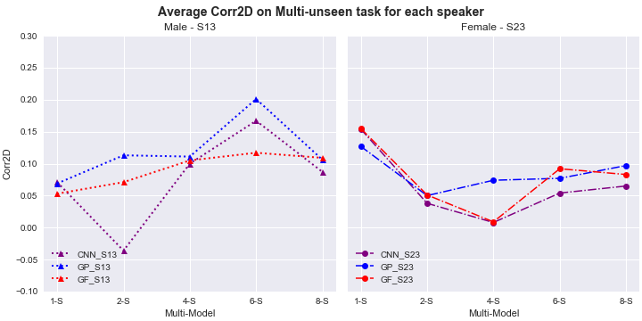

**11.1 Reconstructed spectrogram from male speaker 13.**

*Sample sentence: “BIN BLUE WITH L FIVE AGAIN”*

|  |  |  |  |  |
| --- | --- | --- | --- | --- |
| **8-S** | a(5).8-S | b(5).8-S | c(5). 8-S |  |
| **6-S** | a(4).6-S | b(4).6-S | c(4).6-S |  |
| **4-S** | a(3).4-S | b(3).4-S | c(3).4-S | i(0) |
| **2-S** | a(2). 2-S | b(2).2-S | c(2).2-S |  |
| **1-S** | a(1).1-S | b(1).1-S | c(1). 1-S |  |
|  | **a. Lip2AudSpec system** | **b. GaborLip2AudSpec** | **c. GaborFea2AudSpec** | **i. Original** |

Figure. Comparing the reconstructed spectrogram between our proposed systems (System I: GaborLip2AudSpec b(1)-b(5), System II: Gabor2AudSpec c(1)-c(5)) and the Lip2AudSpec system a(1)-a(5)), using randomly selected sentences: BIN BLUE WITH L FIVE AGAIN

**11.2 Reconstructed spectrogram from male speaker 23.**

*Sample sentence: “BIN BLUE WITH Q NINE AGAIN”*

|  |  |  |  |  |
| --- | --- | --- | --- | --- |
| **8-S** | a(5).8-S | b(5).8-S | c(5). 8-S |  |
| **6-S** | a(4).6-S | b(4).6-S | c(4).6-S |  |
| **4-S** | a(3).4-S | b(3).4-S | c(3).4-S | i(0) |
| **2-S** | a(2). 2-S | b(2).2-S | c(2).2-S |  |
| **1-S** | a(1).1-S | b(1).1-S | c(1). 1-S |  |
|  | **a. Lip2AudSpec system** | **b. GaborLip2AudSpec** | **c. GaborFea2AudSpec** | **i. Original** |

Figure. Comparing the reconstructed spectrogram between our proposed systems (System I: GaborLip2AudSpec b(1)-b(5), System II: Gabor2AudSpec c(1)-c(5)) and the Lip2AudSpec system a(1)-a(5)), using randomly selected sentences: BIN BLUE WITH Q NINE AGAIN